Karel_EC3_ComparisonRobot

Part 1: Compare sections of two Streets for equality.

Copy the folder ComparisonRobot_Student to you work area. Open in BlueJ and compile/execute MainDriver1. (MainDriver2 is for the part 2 of this lab.) A world should appear which contains six ComparingRobots, with walls and single beepers as shown in the following below. (Note: All ComparingRobots are constructed with zero of beepers and three Robots are on corner with one beeper.) Each ComparingRobot is facing down a hallway of different lengths. The Robot task is to traverse the hallway (row) and determine if both streets are equal. In this task, two streets are equal if both streets have a beeper on the same column. While the Robot is allowed to pick up beepers, all beepers MUST be return to their original corner! MainDriver1 does not test to ensure that the beepers have been correctly returned, but the CompareRobotUnitTest does test.
Hint: This problem does not require picking any beepers; simply testing for the presence of a beeper is all that is required.
You’ve correctly implement the task method when successfully passing all in testing units in the CompareRobotUnitTest.
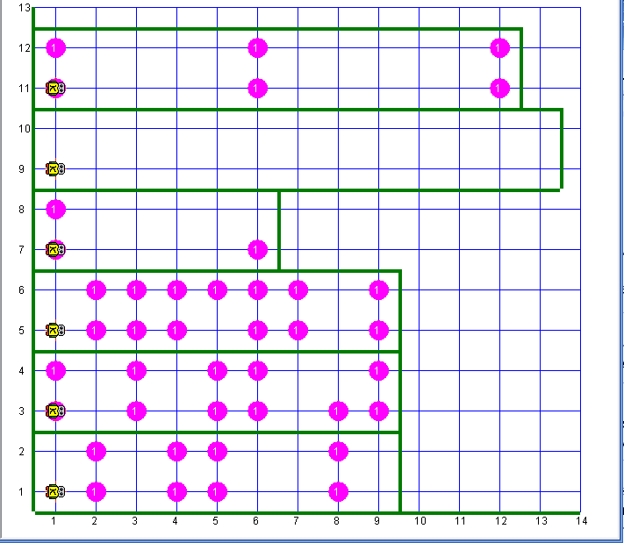
Part 2: Compare sections of two Streets for equality.

The main difference between part 1 and part 2 is part 2 must checks for multiply (> 1) beepers.

Compile/execute MainDriver2. A world should appear which contains six ComparingRobots, with walls and beepers as shown in the following below. (Note: All ComparingRobots are constructed with zero of beepers and three Robots are on corner with one beeper.) Each ComparingRobot is facing down a hallway (row) of different lengths. The Robot task is to traverse the hallway and determine if both streets are equal. In this task, two streets are equal if both streets have the same number of beepers on the same column. While the Robot is allowed to pick up beepers, all beepers MUST be return to their original corner! MainDriver2does not test to ensure the beepers have been correctly returned, but the CompareRobotUnitTest does test.
Hint: This problem does require picking beepers, therefore returning the beepers is a must!
You’ve correctly implement the task method when successfully passing all in testing units in the CompareRobotPart2UnitTest.
